**Interview questions on a git**

**What is Git**

Git is a tool that helps developers manage and track changes in their code. It stores the project’s code and keeps a record of all modifications, making it easier to work with a team. With Git, multiple developers can collaborate on the same project, work on different versions, and merge updates smoothly. This ensures an organized and efficient way to develop software while keeping a history of all changes made over time.

**Who Developed Git?**

* Git was developed by Linus Torvalds, the creator of Linux.
* He designed Git to manage the development of the Linux kernel efficiently.

**Year of Development**

* Git was created in April 2005.
* It was developed after BitKeeper, the previous version control system used for Linux, became unavailable for free.

**Why Was Git Created?**

* To provide a fast, open-source, and distributed version control system.
* To allow multiple developers to collaborate without conflicts.
* To offer better security, tracking, and branching features than older systems.

**Key Features of Git History**

* Records every change made in a project.
* Shows who made changes and when.
* Allows restoring previous versions if needed.
* Helps in debugging and understanding code evolution.
* Tracks merging of different branches in a project.

**Key Uses of Git**

* **Version Control** – Keeps track of every change in a project.
* **Collaboration** – Enables multiple developers to work on the same project.
* **Branching & Merging** – Allows working on different features separately and merging them later.
* **Backup & Security** – Prevents data loss by storing code history.
* **Reverting Changes** – Restores previous versions of code if needed.
* **Open Source & Fast** – Free to use and optimized for performance.

**Common Git Use Cases**

* **Software Development** – Used by programmers to manage codebases.
* **Project Management** – Helps teams track project progress.
* **Documentation Maintenance** – Keeps a history of changes in documents.
* **Configuration Management** – Manages changes in system configurations.

**Advantages of Git**

### ****What Makes Git Beneficial?****

Git is a powerful and widely used version control system that helps developers efficiently manage and track changes in code. It enhances collaboration, improves workflow, and ensures code security.

### ****Key Advantages of Git****

* **Distributed System** – Every developer has a full copy of the project, reducing reliance on a central server.
* **Efficient Collaboration** – Multiple developers can work on the same project without conflicts.
* **Fast Performance** – Git is optimized for speed, handling large projects efficiently.
* **Branching & Merging** – Developers can create separate branches for new features and merge them later.
* **Data Integrity & Security** – Every commit is hashed, ensuring data protection and preventing corruption.
* **Offline Work Capability** – Developers can make commits and work locally without an internet connection.
* **Easy Undo & Rollback** – Previous versions of the project can be restored if needed.
* **Open Source & Free** – Git is free to use, making it accessible for everyone.
* **Extensive Community Support** – Large developer communities provide continuous improvements and help.

### ****Why Developers Prefer Git?****

* Ensures **smooth project management** and prevents accidental data loss.
* Helps **track every change** with detailed commit history.
* Allows **seamless teamwork**, even with remote teams.
* Reduces **conflicts in code** by handling multiple contributions effectively.

**Basic Git Commands**

**What Are Git Commands?**

Git commands help developers manage their projects efficiently by tracking changes, collaborating with teams, and maintaining version control. These commands are essential for working with Git repositories.

**🔹 Initializing & Cloning**

git init – Initializes a new Git repository in a project folder.

git clone [URL] – Copies an existing remote repository to your local system.

**🔹 Tracking & Managing Changes**

git status – Shows the status of changes in the working directory.

git add [file] – Adds a specific file to the staging area.

git add . – Adds all changes to the staging area.

git commit -m "message" – Saves changes with a descriptive message.

**🔹 Branching & Merging**

git branch – Lists all branches in the repository.

git branch [branch-name] – Creates a new branch.

git checkout [branch-name] – Switches to a different branch.

git merge [branch-name] – Merges a branch into the current branch.

**🔹 Working with Remote Repositories**

git remote add origin [URL] – Links a local repository to a remote one.

git push -u origin [branch-name] – Uploads local changes to a remote repository.

git pull – Fetches updates from a remote repository and merges them.

git fetch – Retrieves updates from a remote repository but does not merge.

**🔹 Viewing History & Logs**

git log – Displays the commit history.

git log --oneline – Shows a simplified commit history.

git show [commit-ID] – Displays details of a specific commit.

**🔹 Undo & Reset Changes**

git reset --hard [commit-ID] – Resets the repository to a previous commit, deleting all changes.

git revert [commit-ID] – Reverts a specific commit without losing history.

git stash – Temporarily saves changes without committing.

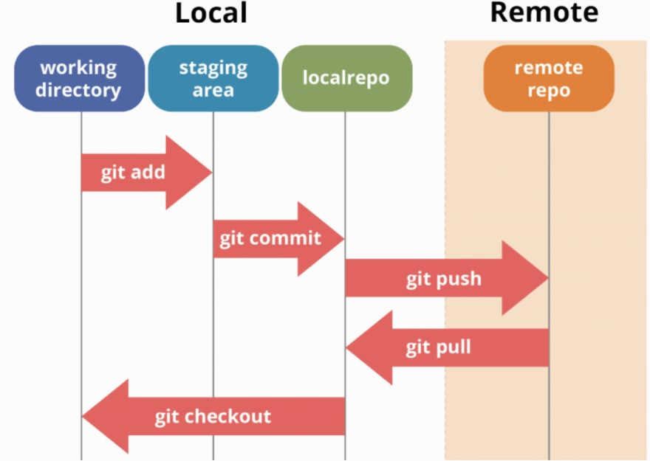git stash pop – Restores stashed changes.

**How Git Works**

Git operates as a distributed version control system, enabling multiple developers to work on a project simultaneously without overwriting each other's changes. It maintains a complete history of all modifications, allowing for easy tracking and rollback if necessary.​

**Key Components of Git Workflow**

1. **Repository (Repo):** A storage space where your project's files and their revision history are kept.​
2. **Working Directory:** The local space where you modify files.​
3. **Staging Area (Index):** A preparatory area where changes are listed before committing.​
4. **Commit:** A recorded snapshot of changes in the repository.​[Git Scripts+4Bryan Braun+4Toptal+4](https://www.bryanbraun.com/2020/04/24/drawing-git-branching-diagrams/)
5. **Branch:** A parallel version of the repository, allowing for feature development isolated from the main codebase.​
6. **Merge:** Combining changes from different branches into one.​
7. **Remote Repository:** A version of the project hosted on the internet or another network.​

**Basic Git Workflow Steps**

1. **Initialize Repository:** Create a new repository using git init.​
2. **Clone Repository:** Copy an existing repository with git clone [URL].​
3. **Create Branch:** Start a new branch for a feature using git branch [branch-name].​
4. **Switch Branch:** Move to the desired branch with git checkout [branch-name].​
5. **Stage Changes:** Add changes to the staging area using git add [file-name] or git add . for all changes.​
6. **Commit Changes:** Save staged changes with git commit -m "commit message".​
7. **Push Changes:** Upload local commits to a remote repository using git push origin [branch-name].​
8. **Pull Changes:** Fetch and merge changes from the remote repository with git pull.​
9. **Merge Branches:** Integrate changes from one branch into another using git merge [branch-name].​

For a visual representation of Git workflows, you can refer to the following diagrams:​

* **Git Workflow Diagram:** This diagram illustrates the role of remote-tracking references and the flow between local and remote repositories.​
* **Git Flow Diagram:** This diagram explains the branching model involving feature, release, and hotfix branches.

**Difference Between "Master" and "Main" Branch in Git**

### ****Understanding the Branches****

In Git, both **"master"** and **"main"** are default branch names used as the primary branch in a repository. However, the default naming convention has evolved over time.

**Key Differences Between "Master" and "Main"**

| **Feature** | **Master Branch** | **Main Branch** |
| --- | --- | --- |
| **Default Usage** | Previously the default branch in Git | The new default branch name in Git (since 2020) |
| **Naming Origin** | Traditionally used by developers | Introduced to promote inclusive language |
| **Git Version** | Older versions of Git used "master" by default | Newer Git versions (since v2.28) default to "main" |
| **Impact on Workflow** | Functions as the primary branch | Functions as the primary branch |
| **Customization** | Can be renamed to "main" or any other name | Can be renamed based on project needs |

**Why the Change from "Master" to "Main"?**

* **Inclusivity** – "Main" is a more neutral and inclusive term.
* **Modern Best Practice** – Many organizations and platforms (like GitHub) now use "main" as the default.
* **No Functional Difference** – Both branches work the same way, but "main" is the preferred naming convention today.

**Key Commands to Change from "Master" to "Main"**

1. **Rename the Current Branch**

git branch -m master main

1. **Update Remote Repository**

git push -u origin main

1. **Set "Main" as the Default Branch** (on GitHub/GitLab)
   * Go to repository settings → Branches → Set "main" as the default.